**A. KPI’s**

**1. Total Revenue:**

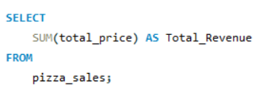

***Output:***

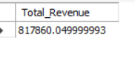

**2. Average Order Value**

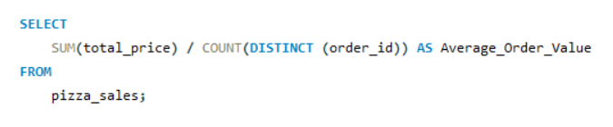

***Output:***

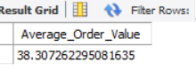

**3. Total Pizzas Sold**

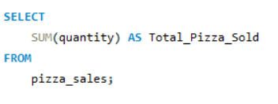

***Output:***

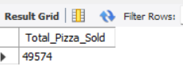

**4. Total Orders**

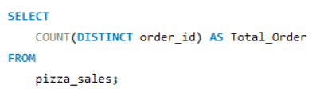

***Output:***

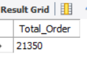

**5. Average Pizzas Per Order**

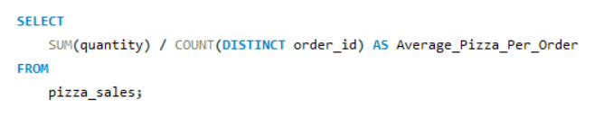

***Output:***

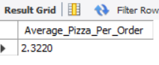

**B. Daily Trend for Total Orders**

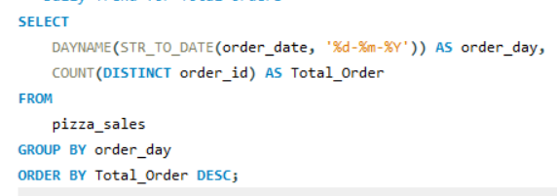

***Output:***

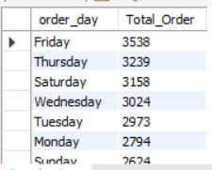

**C. Monthly Trend for Order**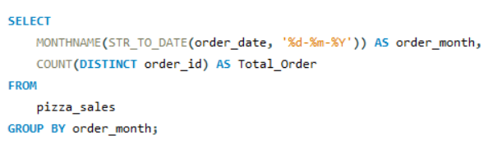

***Output***

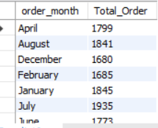

**D. % of Sales by Pizza Category**

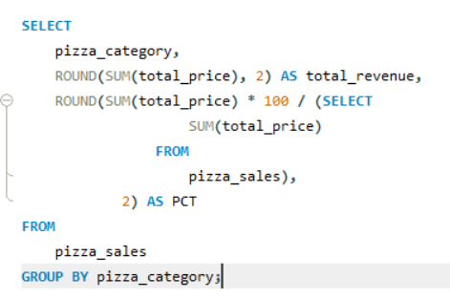

***Output***

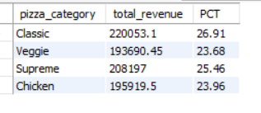

**E. % of Sales by Pizza Size**

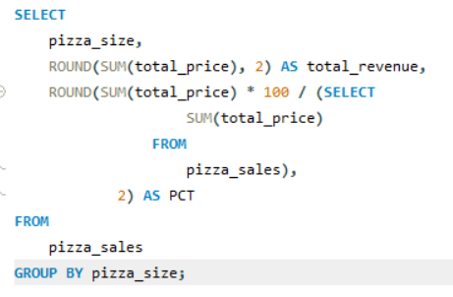

***Output***

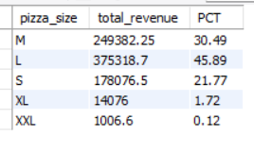

**F. Total Pizzas Sold by Pizza Category**

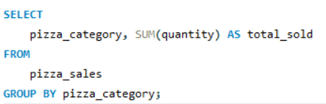

***Output***

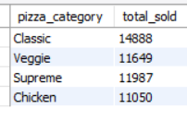

**G. Top 5 Pizzas by Revenue**

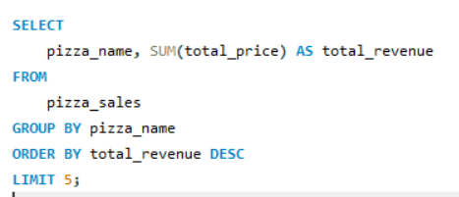

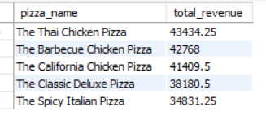

**H. Bottom 5 Pizzas by Revenue**

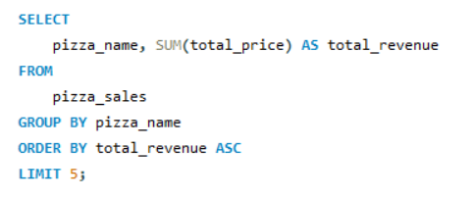

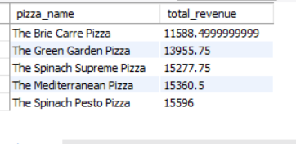

**I. Top 5 Pizzas by Quantity**

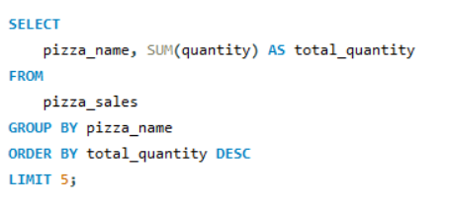

***Output***

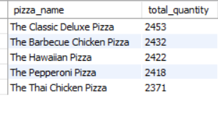

**J. Bottom 5 Pizzas by Quantity**

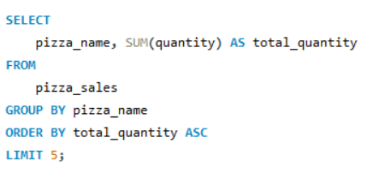

***Output***

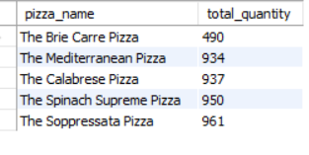

**K. Top 5 Pizzas by Total Orders**

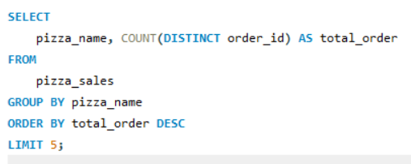

***Output:***

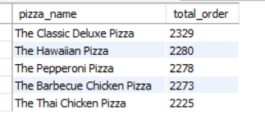

**L. Bottom 5 Pizzas by Total Orders**

